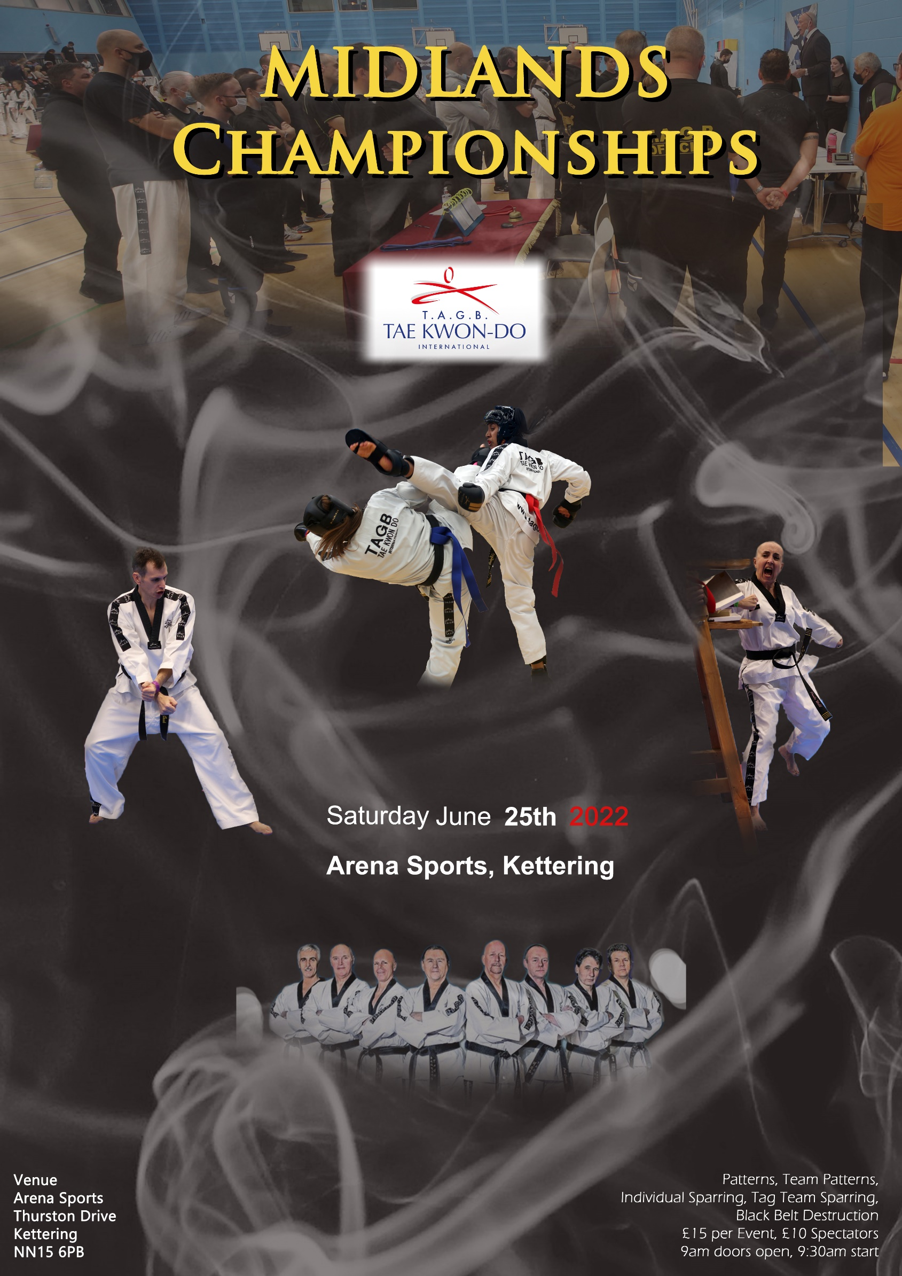

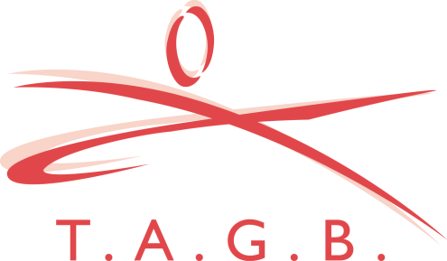
T.A.G.B. MIDLANDS CHAMPIONSHIPS
Arena Sports
Thurston Drive
Kettering
NN15 6PB

Saturday 25th June 2022

Dear Instructor

You and your students are invited to attend the above event.

All competitors to arrive by 9.30 a.m.

The following divisions will apply.

** Please note: There are NO divisions for cadets or executives at this event.!!!!!

Juniors: Up to and including 15 years old.

Adults: 16 years old and above

Closing date for entries will be: Wednesday 15th June 2022.

Payment: Cheques made out to TAE KWON DO.

Entries to be sent to: MR. D. OLIVER. 5 TOLLGATE ROAD, SOUTHAM, WARWICKSHIRE. CV47 1EE.
NOT TO MR. SERGIEW AT ADMIN

Entry fee’s: Competitor: £15 per event (i.e. 3 events = £45).
Spectators: £10.00

TAG teams & Patterns Teams: £15 per 3-person team. To be paid and entered on the day.

**PLEASE WEAR YOUR OFFICIALS WRISTBAND TO GAIN ENTRY**
Officials: Officials must register before the event. Stating their qualification.
Officials Uniform: Officials t-shirt, grey or black pants and sports shoes.
** You must arrive by 9 a.m. otherwise you will be asked to pay to enter. Bring your black belt licence book for stamping to record your attendance.

NO VIDEO CAMERAS PERMITTED ON THE AREA’S.
NO SPECTATORS ALLOWED ON THE AREAS.

PATTERN DIVISIONS:
Juniors: (boys and girls separate) Adults: (male and female separate)
Yellow: 9th Kup to 7th Kup Yellow: 9th Kup to 7th Kup
Green: 6th Kup to 5th Kup Green: 6th Kup to 5th Kup
Blue: 4th Kup to 3rd Kup Blue: 4th Kup to 3rd Kup
Red: 2nd Kup to 1st Kup Red: 2nd Kup to 1st Kup
Black: All grades together Black: All grades together.

BLACK | BLACK | RED | BLUE | GREEN | YELLOW
Sam-Il | Choong Moo | Toi Gye | Yul Gok | Do San | Chon Ji
Yoo Sin | Kwang Gae | Hwa Rang | Joong Gun | Won Hyo | Dan Gun
Choi Young | Gae Baek | Choong Moo | Toi Gye | Yul Gok | Do-San
Tong-Il | Po-Eun
Ul-Ji | Ko-Dang
Se-Jong | Choi Jang
Yon-Ge | Eui-Am
Moon-Moo

So San

SPARRING DIVISIONS
JUNIOR: Boys and Girls separate.
BLACK  Continuous | RED  Point stop | BLUE  Point stop | GREEN  Point stop | YELLOW  Point stop
PEE WEE  Over 122cm up to & inc 137cm | PEE WEE  Over 122cm up to & inc 137cm | PEE WEE  Over 122cm up to & inc 137cm | TINY TOTS  Under 122cm | TINY TOTS  Under 122 cm
LIGHTWEIGHT  Over 137cm up to & inc 152cm | LIGHTWEIGHT  Over 137cm up to & inc 152cm | LIGHTWEIGHT  Over 137 cm up to & inc 152cm | PEE WEE  Over 122cm up to  & inc 137cm | PEE WEE  Over 122 cm up to & inc 137cm
MIDDLEWEIGHT  Over 152cm up to & inc 168cm | MIDDLEWEIGHT  Over 152cm up to & inc 168cm | MIDDLEWEIGHT  Over 152cm up to & inc 168cm | LIGHTWEIGHT  Over 137cm up to & inc 152cm | LIGHTWEIGHT  Over 137m up to & inc 152cm
HEAVYWEIGHT  Over 168cm | HEAVYWEIGHT  Over 168cm | HEAVYWEIGHT  Over 168cm | MIDDLEWEIGHT  Over 153 cm up to  & inc 168cm | MIDDLEWEIGHT  Over 153cm up to  & inc 168cm
 |  |  | HEAVYWEIGHT  Over 168cm | HEAVYWEIGHT  Over 168cm

ADULT FEMALE SPARRING DIVISIONS:
BLACK  Continuous | RED  Continuous | BLUE  Continuous | GREEN  Point stop | YELLOW  Point stop
LIGHTWEIGHT  Up to & inc 55kg | LIGHTWEIGHT  Up to and inc 55kg | LIGHTWEIGHT  Up to & inc 55kg | LIGHTWEIGHT  Up to & inc 55kg | LIGHTWEIGHT  Up to & inc 55kg
MIDDLEWEIGHT  Over 55kg up to & inc 61kg | MIDDLEWEIGHT  Over 55kg up to & inc 61kg | MIDDLEWEIGHT  Over 55kg up to & inc 61kg | MIDDLEWEIGHT  Over 55kg up to & inc 61kg | MIDDLEWEIGHT  Over 55kg up to & inc 61kg
LIGHT HEAVY  Over 61kg up to & inc 67kg | LIGHT HEAVY  Over 61kg up to & inc 67kg | LIGHT HEAVY  Over 61kg up to & inc 67kg | LIGHT HEAVY  Over 61kg up to & inc 67kg | LIGHT HEAVY  Over 61kg up to & inc 67kg
HEAVYWEIGHT  Over 67kg | Heavy  Over 67kg | Heavy  Over 67kg | Heavy  Over 67kg | Heavy  Over 67kg

ADULT MALE SPARRING DIVISIONS:
BLACK  Continuous | RED  Continuous | BLUE  Continuous | GREEN  Point stop | YELLOW  Point stop

FLYWEIGHT
Up to & inc 58kg
LIGHTWEIGHT  Over 58kg up to & inc 64kg | LIGHTWEIGHT  Up to & inc 64kg | LIGHTWEIGHT  Up to & inc 64kg | LIGHTWEIGHT  Up to & inc 64kg | LIGHTWEIGHT  Up to & inc 64kg
WELTERWEIGHT  Over 64kg up to & inc 70kg | WELTERWEIGHT  Over 64kg up to & inc 72kg | WELTERWEIGHT  Over 64kg up to & inc 72kg | WELTERWEIGHT  Over 64kg up to & inc 72kg | WELTERWEIGHT  Over 64kg up to & inc 72kg
MIDDLEWEIGHT  Over 70kg up to & inc 76kg | MIDDLEWEIGHT  Over 72kg up to & inc 80kg | MIDDLEWEIGHT  Over 72kg up to & inc 80kg | MIDDLEWEIGHT  Over 72kg up to & inc 80kg | MIDDLEWEIGHT  Over 72kg up to & inc 80kg
LIGHT HEAVY
Over 76kg up to & inc 82kg

HEAVYWEIGHT  Over 82kg | HEAVYWEIGHT  Over 80kg | HEAVYWEIGHT  Over 80kg | HEAVYWEIGHT  Over 80kg | HEAVYWEIGHT  Over 80kg

DESTRUCTION (BLACK BELT ADULTS ONLY)

MALE HAND | MALE FOOT | FEMALE HAND | FEMALE FOOT.
Any hand technique  (not elbow) | Any standing rear leg  kick | Any hand technique | Any foot technique

RULES OF THE TAG TEAM SPARRING.

ALL TEAM EVENTS TO START AFTER THE INDIVIDUAL EVENTS.

Teams will consist of a 3 person team: bouts will be for 4 minutes. Each time the bout is stopped you can change with a member of your team by tagging your team member’s glove. All 3 members must fight at some stage during the bout. All team matches will be point stop.

TAG TEAM SPARRING DIVISIONS

** PLEASE NOTE: YELLOW/GREEN & BLUE ARE NOW TOGETHER. RED & BLACK BELTS TOGETHER FOR THIS EVENT ONLY.

MALE:
3 person team. Yellow/Green & Blue belts together. No weights
3 person team. Red/Black belts together. No weights

FEMALE:
3 person team. Yellow/green& Blue belts together. No weights
3 person team. Red & Black belts together. No weights

JUNIOR’S. (boys and girls separate)
3 person team. Yellow/Green & Blue belts together. Must all be same height
3 person team: Red/Black belts together. Must all be same height
.

*There will be four junior divisions:
- Pee wee
- Lightweight
- Middleweight
- Heavyweight.

All junior teams are under 15 years old and all senior teams are 16 and over.

TEAM PATTERNS

Divisions

Juniors - Boys and Girls in same divisions

Three competitors in a team

Split as follows

9th kup to 7th kup

6th kup to 4th kup

3rd kup to ls kup

All Dan Grades

Adults - Males and Females in same division

Three competitors in a team

Split as per junior divisions

RULES OF THE COMPETITION

Each team to perform a pattern unison.

Pattern to be scored in the same way as in individual pattern events.

The pattern to be relevant to the most junior grade in the team.

(eg A team with a 9th Kup in can only perform Chon Ji and a team with a 3'd kup in can perform any pattern up to and including Toi Gye)

Scoring to be based on the following:-

1. The correctness of the pattern moves

2. Power, balance, focus, fluidity etc. As per individual pattern competition.

3. Synchronisation of all members when performing the pattern.

Cost £5.00 per competitor. Same as TAG team event.

ENTRY ON THE DAY.

